**Anchoveta consumption of guano bird populations in Peru between 1953 and 2009**

Elisa Goya1, Jaime Silva1, Dante Espinoza1 y Jorge Díaz2

1. Instituto del Mar del Perú (2) AGRORURAL

**Summary**

In this study we present monthly population estimates of guanay cormorant *Phalacrocorax* *bougainvillii*, Peruvian booby *Sula variegata* and Peruvian pelican *Pelecanus thagus* living on guano headlands and islands from 1953-2009 in Peru between 6 and 14 ° Latitude South (LS). We analyzed fluctuations in the populations of the three bird species, their relationship with the occurrence of El Niño events and the development of the industrial anchoveta fishery and showed changes in the spatial distribution of the main colonies during this period. Based on estimates of monthly population, we calculated monthly consumption of anchoveta by the three guano bird species between 1953 and 2009.

Keywords: Guanay, Peruvian boobies, pelicans, Peruvian anchoveta fishery industry, El Niño events.

**Introduction**

Seabirds are an important component in the Humboldt Current Upwelling Ecosystem. Endemic birds are the most abundant in this system and are distributed along guano headlands and islands of the coast of Peru forming extremely dense colonies that support up to more than 500,000 individuals. Their diet is mainly based on the Peruvian anchoveta *Engraulis ringens ringens* (Jordán 1959, Jordán 1961, Galarza 1968, Schaefer 1970, Duffy 1983, Tovar et al. 1988, Tovar y Guillén 1989, Jahncke y Goya 1997, 1998, Goya 2000, Crawford et al. 2006).

The guanay is a highly colonial diving seabird that feeds on anchoveta or other small pelagic fish (Jahncke y Goya, 1997). They congregate in thousands to feed and use the colony as a source of information to localize schools of anchoveta (Weimerskirch et al., 2010). Meanwhile, the Peruvian booby and the Peruvian pelican have a different foraging strategy. These species are surface foragers and can search for prey in solitude. Guano birds (known as the conjunction of guanay cormorants, Peruvian boobies and Peruvian pelicans) have evolved in a highly productive, complex and variable environment. The features of this ecosystem have caused large fluctuations in the populations of guanay cormorants, Peruvian boobies and Peruvian pelicans, reducing numbers dramatically when an El Niño occurs and decreases availability and access to anchoveta (Murphy 1925, Vogt 1940, Jordán y Fuentes 1966), while then promoting a rapid recovery of the population when environmental conditions are favorable. Researchers suggest that unstable populations, as is the case of guano birds, demographic “boom/burst” strategies have been selected as a consequence of living in constantly changing environments (Weimerskirch, 2002). Fluctuations in guano bird populations through time have generated cycles of declining abundance in the last 56 years. This trend coincides with the development of the industrial anchoveta fishery that began in 1950. Since then, this activity has become another top predator that competes with guano birds for prey. And, when anchoveta availability is low during El Niño events, negative pressure on guano bird population growth rates worsen, allowing only partial population recovery.

Since the 1970s, scientists have recognized the importance of guano birds as indicators of changes produced in marine ecosystems. For example, some species serve as indicators of fish stocks (Cairns, 1987 Furness and Camphuysen, 1997, Montevecchi, 1993, Piatt et al., 2007). In the case of guano birds, changes in diet composition, reproductive performance and variability in population size (due to mortality and/or dispersal) are related to changes in abundance, spatial distribution and anchoveta availability.

In the past two years recognizing that marine resource management should follow an ecosystem-based focus has promoted changes in the anchoveta fisheries and the recent establishment of a network of marine protected areas for guano islands and headlands in Peru. These measures aim to improve the anchoveta fishery and protect guano bird populations.

This study updates the time series available for guano birds in Peru from 1953 to 2009, and following Tovar et al. (1987), we discuss the factors that determine the current trend. Additionally, we estimated the consumption of anchoveta by each of the three species of guano birds following the model in Muck and Pauly (1987).

**Materials and Methods**

***Guano bird counts***

Monitoring of guano bird populations first began under the conduction of the Guano Administration Company (Compañía Administradora del Guano, CAG) by the allocation of guards on islands and headlands between 1909 and 1940. Between 1909 and 1952, the annual population abundance was estimated from the volume of guano extracted (Jordán y Fuentes 1966). In the 1950´s, estimations of population abundance were done based on graphic surveys. To transform guano production into number of birds, we used a value of 15.9 kg of guano produced per guanay cormorant/ year as calculated by Vogt (1942).

Since 1953, abundance of guano birds has been estimated through a graphic survey as described by Jordán (1963). This consists of elaborating gridded maps of the islands and peninsulas (based on aerial photography). On the grids, areas occupied by non-reproductive adults, adults incubating eggs, chicks and juvenile birds were drafted. We then estimated abundance from graphs planimetrically by recording: density of birds in the colony according to each species and a scaling factor to convert the map from hectares to m2. Thus, in each map the abundance of adults, eggs, chicks and juveniles of each species were registered.

Population records of guano birds between 1953 and 1982 between 6° S and 14° S were taken by Tovar et al. (1987). Data for years 1984 to 1989 were collected by Guillén (1992) and data for March, May, June and July of 1983 were taken by Tovar and Cabrera (1985, as cited by Arntz and Fahrbach 1996). Population of guano birds between 1990 and 2004 were estimated from maps produced by PESCA PERU and then by PROABONOS. The estimate for each species was calculated using empirical density estimates proposed by Tovar et al. (1987).

Between 1983 and 2009, monthly population estimates of guano birds were calculated using Singular Spectrum Analysis (SSA) (Komdrashov and Ghil, 2006) which allowed us to complete missing gaps in the time series of some of the islands for which no information was collected. SSA methodology is based on elements that pertain to time series analyses, multivariate analyses, dynamic systems and signal processing analyses. SSAs main goal is to describe the main features of the time series, such as the trend, fluctuations and noise (Musial et al. 2011).

**Results and Discussion**

***Updating the 1953 – 2009 time series***

For the period between 1983 and 2009 monthly population estimates of guano birds were achieved using SSA. To ensure that this was the right methodology, we took a time series from Mazorca Island and removed data points that pertained to peaks in the series. Results in Figure 1 shows how SSA best represents fluctuations in the series in comparison to linear interpolation that is traditionally used (Tovar et al. 1987). However, this methodology also has limitations, not being able to fill in data gaps for time series that do not have strong enough signals or for time series that were lacking information for the last months of the study period. To solve this, we calculated the mean average that the site contributed towards the total population to fill in the missing data point.



**Fig. 1**. Abundance time series at Mazorca Island (2000-2005) with artificial gaps (line), gaps filled with real data (thick dashed line), gaps filled by interpolation (circles) and the methodology used in this study (thin dashed line).

***Guano bird population 1953 to 2009***

Throughout history, guano bird populations have suffered dramatic fluctuations due to natural factors like El Niño events and to human induced factors. The most important human borne activities include (i) the harvest of guano to use as fertilizer, (ii) the protection of guano islands and headlands by the Compañía Administradora del Guano since 1909, and (iii) industrial anchoveta fishery since 1952; having the latter become a top predator that competes with birds for anchoveta as prey. Thus, in the past 56 years guano bird populations present a clear decreasing trend, with 36.17 million birds in 1955 to 2.09 million birds in 2009 (Figure 2).

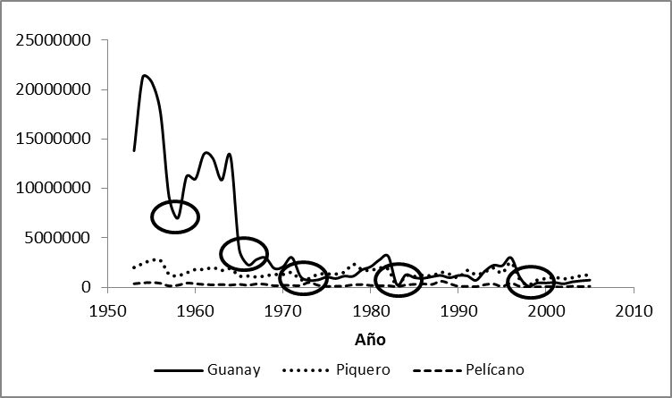

**Fig. 2.** Abundance of guano birds by species between 1953 and 2009 between 6° S and 14°S. Black circles indicate the occurrence of El Niño events in 1957/58, 1965/66, 1972/73, 1982/83 and 1997/98.

The Peruvian boobie population seem to remain relatively stable at 1,5 million individuals, meanwhile the story for guanay cormorants and Pelicans is quite different, constantly showing a decreasing trend. Currently, guanay and pelican populations represent less than 10% and 25% of their maximum historical values, making them the most affected guano birds. The confluence of various factors, such as the industrial anchoveta fishery, incidental captures, direct poaching, bad practices during guano harvests and a more frequent occurrence of El Niño events have not allowed the recovery of their populations.

In general, researchers have observed an increase in the time   
(in years) that it takes for guano birds to recover from a decline in their populations. For example, in the case of the guanay cormorant, 14 years had to pass to between 1983 and 1997 for the population to recover to the levels observed in 1982 (Figure 2).

As the number of bird guano has diminished, changes in the proportion that each species contributes to the total population (relative abundance) of guano birds has changed. For example, in 1962 the guanay was by far the most abundant species (82.38%), which was followed by the Peruvian booby (15.29%) and then by the pelican (2.33%). In 2009 (September) the guanay cormorant was most abundant (49.53%), followed by the Peruvian booby (46.26%) and then by the pelican (4.21%). Alternating order between the booby and guanay on which is most abundant, has been observed since 1972. These situations have arisen after El Niño events in which the guanay has had higher mortality rates (Figure 3). Thus, in the period from 2000 to 2008, the Peruvian booby was the most abundant guano bird in the area between 6 ° S and 14 ° LS.

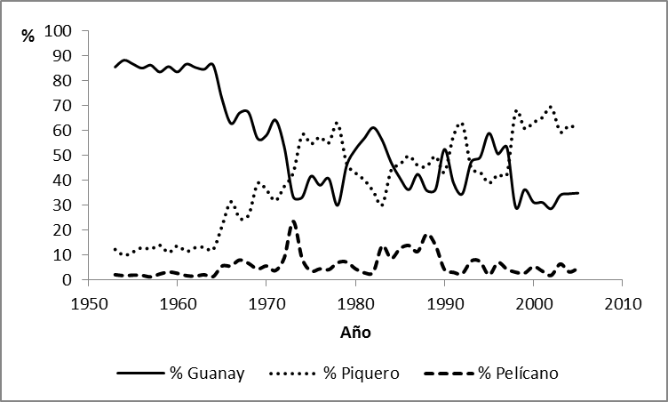

**Fig 3.** Relative abundance of sea birds in the period 1953-2009 and the area between 6 ° S and 14 ° S

***Guano bird distribution***

During our study period we have observed changes in the distribution of colonies along the Peruvian coast. While in the 1960´s major colonies were: Punta Culebras (Ancash) with 3.23 million birds (99% guanay) Guañape North Island (La Libertad) with 1.61 million birds and the North Chincha Island (Ica) with 1.18 million birds in 2009, Punta Culebras no longer has a residential population and the two largest colonies are Guañape South Island and Macabí (La Libertad) with 0.7 and 0.5 million birds, respectively. Figure 4 shows the changes in distribution that have occurred in the colonies of guano birds between 1962 and 2005.

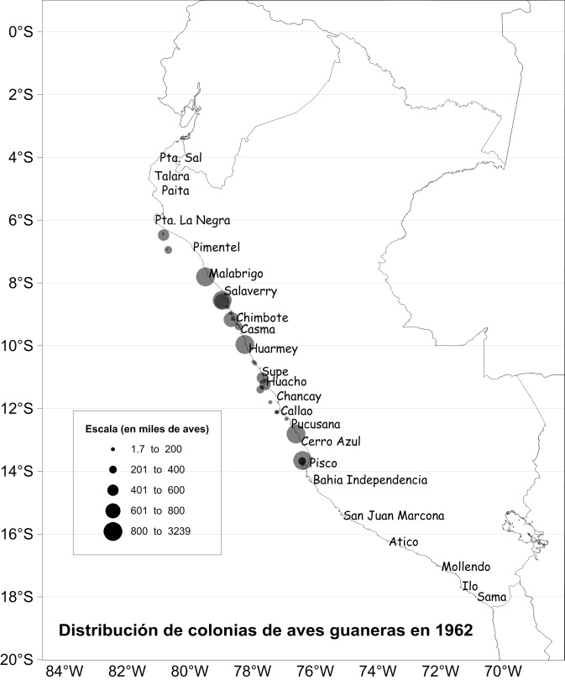

**Fig 4.** Distribution of the main colonies of guano birds between 6 ° and 14 ° S for the period 1962-2005

***Guano birds between 1953 and 2009, their relationship with the occurrence of El Niño and the industrial anchoveta fishery***

Guano birds have evolved in a highly variable environment where the occurrence of El Niño events reduce their populations by affecting the supply and availability of food. At the same time, these birds show rapid recovery when conditions become favorable again, generating cyclical fluctuations in the population levels in the three species of guano birds. During the first half of the 20th century they have showed an increasing trend despite the fact that 13 El Niño events occurred, 5 of which were classified as "strong" (Quinn et al., 1978). The establishment of protected areas by the Compañía Administradora del Guano (established in 1909) was a factor influencing growth of guano bird populations by increasing available space for nesting birds and protection of their populations. This is why in 1954, the maximum number of guano birds in history was estimated between 6 and 14LS, at 24 million individuals.

Between 1957 and 1973, the largest population decline in the guano bird population occurred. During this time, 5 El Niño events took place that had different effects on the population of guano birds, three of these: the 57/58 ("Strong"), 65/66 ("Moderate") and 72/73 ("Strong") El Niño’s largely affected the guano bird population abundance. During the occurrence of 1957/58 El Niño guano bird mortality was estimated at 60% (Jordan and Fuentes, 1966), whereas during the 1965/66 El Niño bird mortality was 76% (mortality of guanay was 83%, booby 40% and pelicans 5%) and occurred at a time when anchoveta catch in the north central area was more than 6 million tonnes per year, allowing overfishing to worsen the effects of what was a "moderate" El Niño event.

At the end of the 1960's landings reached 10 million tonnes per year (between 1966 and 1970 alone, landings averaged 9.09 million MT/year, see Figure 5). In 1971, this trend continued and another 9 million tonnes were landed. The following year was the 1972/73 El Niño event, during which 77% guanay, 41% booby and 5% pelican mortality was estimated (Tovar and Galarza, 1983).

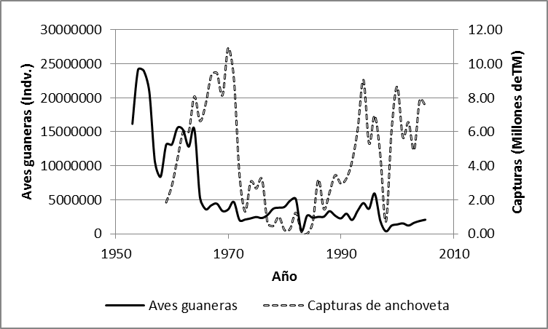

**Fig 5.** Annual average guano bird population (continuous line) and annual landings of anchoveta (dashed line) in the period 1953-2009 for the area between 6 ° S and 14 ° S.

After the occurrence of this high mortality of guano birds, populations were not able to recover to previous levels. This got worse in the last two decades of the past century with the occurrence of the 1982/1983 and 1997/1998 El Niño’s (which have the highest recorded values according to the Oceanic El Niño Index from NOAA). Due to the effects of these events, the historical minimum was recorded (a total of 0.37 million birds in 1998) and a strong migration of birds towards the south of Peru (from 15 ° S) began with the 1997/98 El Niño (Paz Soldan and Jahncke, 1998). Additionally, guano bird mortality was high during both of these events, being estimated that during the 1982/83 El Niño there was a mortality of 58% in adult birds (Arntz and Fahrbach, 1996) and during the 1997/98 El Niño 67% of the adult guanay population, 34% of the Peruvian booby and 58% of the pelican population died.

***Extraction of guano islands***

The annual extraction of island guano in Peru during the period of 1953-2009 decreased following the trend shown by the populations of birds, varying from over 159 thousand tonnes in 1965 to 33 thousand tons in 1973, time when this activity was conducted by CONAFER. After this, guano mining activities have been undertaken by various institutions or programs. Between 1974 and 2001 PESCA PERU Fertilizers undertook it, then in 2001 a governmental program called PROABONOS conducted it, which has recently turned into AgroRural in 2009. In the past 2 years the target of guano that is to be removed from islands is around 20 thousand tons, which means increased pressure on declining populations of guanays, boobies and pelicans. This situation should encourage the review and subsequent reduction of guano extraction targets so as to achieve sustainable management of this resource.

Poor planning or execution of guano mining campaigns will immediately become a factor affecting the reproductive performance of guano birds, especially if extraction occurs on a guano island or headland during the reproductive cycle of one of the three species.

***Estimated anchoveta consumption by guano birds during 1953-2009***

Anchoveta consumption by guano birds was calculated using the model proposed by Muck and Pauly (1987). The model takes into account total possible consumption by birds (*C*) and the availability of anchoveta towards predators (*Aa*). The total consumption of anchoveta in month "i" (*Cai*) is explained as:



Where *Bai*, *Vuli*, *Compi* are anchoveta biomass, anchoveta vulnerability, and competition for anchoveta in month *"i"*, respectively. In addition, *Bij* and *PDC%j* are biomass estimates for species *"j"* in month *"i"* and the possible daily intake by species *"j"*, respectively.

Model inputs were taken from different sources (Figure 6):

• Guano bird biomass was obtained from the reconstruction of the abundance of each species estimated in this study, multiplied by their corresponding weights (Muck and Pauly, 1987).

• Monthly anchovy biomass was collected in two periods: January 1953 to December 1960 (Pauly et al., 1987) and January 1961 to December 2009 (Oliveros and Peña, 2011).

• Average water temperature (Chimbote-Chicama-Callao) and the monthly exploitation rate used to find anchoveta availability for predators was provided by The Oceanic Research Division and Pelagic Resources Division of IMARPE, respectively.



**Fig 6.** Time series (annual means) of the variables affecting the consumption of anchoveta off Peru by guano birds (4 ° S-14 º S), 1953-2009

***Anchoveta consumption of guano birds in the period 1953-2009***

The model reproduced previous estimates of anchoveta consumption by guano birds effectively. However, our estimates of consumption during the first decade of study (less than 1.2 million tons) differ from those estimated by Muck and Pauly (1987) (by around 2 million tons) because the model is susceptible to changes in anchoveta biomass. Figure 7 shows the annual consumption of anchoveta and the possible total annual consumption of anchoveta by the guano birds.

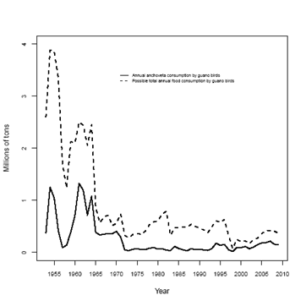

**Fig 7.** Annual anchoveta biomass and total possible anchoveta consumption by guano birds off Peru (4 ° S-14 º S), 1953-2009.

Figure 8 shows a comparison between anchoveta landings and the relative consumption by guano birds. Ever since the moderate 1991/93 El Niño relative consumption fluctuates around 3.2%.

Figure 9 shows the changes in the relative importance of anchoveta consumption by the different species of guano birds. One can observe that after a severe El Niño event, the Peruvian booby populations recover more quickly than guanay.

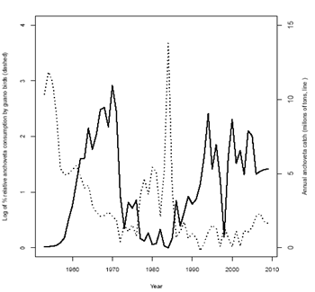

**Fig. 8.** Annual anchoveta catch by the fishery (black line), compared with the relative anchoveta consumption (dashed line) by guano birds off Peru (4ºS-14ºS), 1953 to 2009

Figure 9 shows the changes in the relative importance of anchoveta consumption by the three species of guano birds. One can observe that after a severe El Niño event, the Peruvian booby populations recover more quickly than guanay.

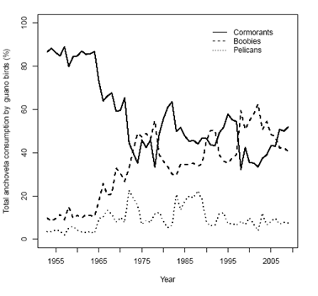

**Fig 9.** Changes in the relative importance of anchoveta consumption by the three major bird species in the Peruvian upwelling ecosystem, 1953 to 2009

**Acknowledgments:**

We would like to thank AgroRural for providing the data on guano bird populations for the period 2005-2009, Marilu Bouchon from the Population Dynamics Unit for providing anchovy biomass and landings data. A special thanks to Delia Vega, Regina Aguilar, Evelyn Paredes, Maria Andrea Tello and Sofia Rivadeneyra for their enormous help with the census data of birds.